
ACCIDENT DETECTION AND ALERT SYSTEM USING SMARTPHONE SENSORS
A MINI PROJECT REPORT
Submitted by
ABHISHIKTH S SIBY
MLM25MCA-2004
To
the APJ Abdul Kalam Technological University in
Partial fulfillment of the requirements for the
award of the degree
of
MASTER OF COMPUTER APPLICATIONS
Under the Guidance of
Ms. ANJU JOHN
(Assistant Professor, Department of Computer Applications)

DEPARTMENT OF COMPUTER APPLICATIONS
MANGALAM COLLEGE OF ENGINEERING, ETTUMANOOR
(Affiliated to APJ Abdul Kalam Technological University)
OCTOBER 2026
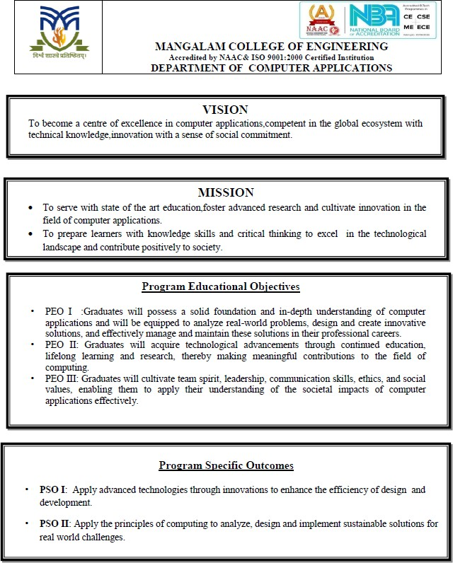
MAPPING OF PO-PSO-SDG
1. MAPPING WITH PROGRAM OUTCOMES (POs):
SL.NO | POs ADDRESSED | RELEVANCE TO PROJECT
1 | PO1 - Foundation Knowledge | Uses programming logic, mathematical magnitude calculation and mobile development fundamentals for sensor-based accident detection.
2 | PO2 - Problem Analysis | Analyses delayed emergency response, false alerts, device permissions and sensor-threshold problems.
3 | PO3 - Development of Solutions | Develops a practical smartphone safety application combining sensors, GPS, alarm and SMS.
4 | PO4 - Modern Tool Usage | Applies Flutter, Dart, sensors_plus, geolocator, SharedPreferences and Android SDK tools.

LIST OF PROGRAM OUTCOMES (POs):
PO1 (Foundation Knowledge): Apply knowledge of mathematics, programming logic and coding fundamentals for solution architecture and problem solving.
PO2 (Problem Analysis): Identify, review, formulate and analyze problems for primarily focusing on customer requirements using critical thinking frameworks.
PO3 (Development of Solutions): Design, develop and investigate problems with as an innovative approach for solutions incorporating ESG/SDG goals.
PO4 (Modern Tool Usage): Select, adapt and apply modern computational tools such as development of algorithms with an understanding of the limitations including human biases.
PO5 (Individual and Teamwork): Function and communicate effectively as an individual or a team leader in diverse and multidisciplinary groups. Use methodologies such as agile.
PO6 (Project Management and Finance): Use the principles of project management such as scheduling, work breakdown structure and be conversant with the principles of Finance for profitable project management.
PO7 (Ethics): Commit to professional ethics in managing software projects with financial aspects. Learn to use new technologies for cyber security and insulate customers from malware.
PO8 (Life-long learning): Change management skills and the ability to learn, keep up with contemporary technologies and ways of working.
2. MAPPING WITH PROGRAM SPECIFIC OUTCOMES (PSOs):
SL.NO | PSOs ADDRESSED | RELEVANCE TO PROJECT
1 | PSO 1 | Applies smartphone sensing and modern mobile frameworks to build an innovative safety application.
2 | PSO 2 | Designs and implements a sustainable, low-cost solution to a real-world emergency-response problem.

LIST OF PROGRAM SPECIFIC OUTCOMES (PSOs):
PSO 1: Apply advanced technologies through innovations to enhance the efficiency of design development.
PSO 2: Apply the principles of computing to analyze, design and implement sustainable solutions for real world challenges.
3. MAPPING WITH SUSTAINABLE DEVELOPMENT GOALS (SDGs):
SDG NO | SDGs ADDRESSED | RELEVANCE TO PROJECT
3 | Good Health and Well-Being | Faster detection and emergency notification can support timely medical assistance after accidents.
9 | Industry, Innovation and Infrastructure | Demonstrates innovative use of smartphone infrastructure and embedded sensors for safety.
11 | Sustainable Cities and Communities | Supports safer mobility and more responsive urban and rural transport environments.

SUSTAINABLE DEVELOPMENT GOALS (SDGs):
SDG 1 – No Poverty: End poverty in all its forms everywhere.
SDG 2 – Zero Hunger: End hunger, achieve food security and improved nutrition, and promote sustainable agriculture.
SDG 3 – Good Health and Well-Being: Ensure healthy lives and promote well-being for all at all ages.
SDG 4 – Quality Education: Ensure inclusive and equitable quality education and promote lifelong learning opportunities for all.
SDG 5 – Gender Equality: Achieve gender equality and empower all women and girls.
SDG 6 – Clean Water and Sanitation: Ensure availability and sustainable management of water and sanitation for all.
SDG 7 – Affordable and Clean Energy: Ensure access to affordable, reliable, sustainable, and modern energy for all.
SDG 8 – Decent Work and Economic Growth: Promote sustained, inclusive, and sustainable economic growth, full and productive employment, and decent work for all.
SDG 9 – Industry, Innovation, and Infrastructure: Build resilient infrastructure, promote inclusive and sustainable industrialization, and foster innovation.
SDG 10 – Reduced Inequality: Reduce inequality within and among countries.
SDG 11 – Sustainable Cities and Communities: Make cities and human settlements inclusive, safe, resilient, and sustainable.
SDG 12 – Responsible Consumption and Production: Ensure sustainable consumption and production patterns.
SDG 13 – Climate Action: Take urgent action to combat climate change and its impacts.
SDG 14 – Life Below Water: Conserve and sustainably use the oceans, seas, and marine resources.
SDG 15 – Life on Land: Protect, restore, and promote sustainable use of terrestrial ecosystems, manage forests sustainably, combat desertification, halt and reverse land degradation, and halt biodiversity loss.
SDG 16 – Peace, Justice, and Strong Institutions: Promote peaceful and inclusive societies, provide access to justice for all, and build effective, accountable, and inclusive institutions.
SDG 17 – Partnerships for the Goals: Strengthen the means of implementation and revitalize the global partnership for sustainable development.

MANGALAM COLLEGE OF ENGINEERING, ETTUMANOOR
DEPARTMENT OF COMPUTER APPLICATIONS
OCTOBER 2026
DECLARATION
I hereby certify that the work presented in the project entitled “ACCIDENT DETECTION AND ALERT SYSTEM USING SMARTPHONE SENSORS” submitted to the DEPARTMENT OF COMPUTER APPLICATIONS is an authentic record of my own work carried out under the supervision of Ms. Anju John, Assistant Professor. This work has not been submitted to any other institution or university for the award of any other degree. The report has been checked for plagiarism by the college and the similarity index is within the permissible limit set by the college.

Name & Signature of Student
ABHISHIKTH S SIBY
Date:
Place:

MANGALAM COLLEGE OF ENGINEERING, ETTUMANOOR
DEPARTMENT OF COMPUTER APPLICATIONS
OCTOBER 2026
CERTIFICATE
Certified that the report entitled “ACCIDENT DETECTION AND ALERT SYSTEM USING SMARTPHONE SENSORS” submitted by ABHISHIKTH S SIBY (MLM25MCA-2004) to the APJ Abdul Kalam Technological University in partial fulfillment of the requirements for the award of the Degree of Master of Computer Applications is a bonafide record of the MINI PROJECT work carried out by the student under our guidance and supervision during the academic year 2025-27.

PROJECT GUIDE  Ms. Anju John  Assistant Professor  Department of Computer Applications | PROJECT COORDINATOR  Ms. Athira R Kurup  Assistant Professor  Department of Computer Applications
HEAD OF THE DEPARTMENT  Ms. Divya S B  Associate Professor  Department of Computer Applications | EXTERNAL EXAMINER
ACKNOWLEDGEMENT
I am greatly indebted to the authorities of Mangalam College of Engineering for providing the necessary facilities to successfully complete my Project on the topic “Accident Detection and Alert System Using Smartphone Sensors”.
I express my sincere thanks to Dr. Vinodh P Vijayan, Principal, Mangalam College of Engineering, for providing the facilities and academic environment required to complete my Project successfully.
I thank and express my sincere gratitude to Ms. Divya S B, HOD, Department of Computer Applications, Mangalam College of Engineering, for her valuable support and encouragement, which helped me in successfully completing this Project work.
I express my gratitude to my Internal Guide, Ms. Anju John, Assistant/Associate Professor, Department of Computer Applications, for her suggestions, technical guidance and encouragement, which helped in the successful completion of my Project.
Furthermore, I would like to acknowledge with much appreciation the crucial role of the faculties, especially the Project Coordinator, Ms. Athira R Kurup, Department of Computer Applications, Mangalam College of Engineering, who gave me the necessary guidance, resources and coordination required to complete the project presentation and report.
Finally, I would like to express my heartfelt thanks to my parents, friends and well-wishers for their continuous support, encouragement and motivation throughout the completion of this Project.

ABHISHIKTH S SIBY
MLM25MCA-2004

ABSTRACT
The first minutes after a serious road accident are critical, yet a victim who is injured, unconscious or trapped may be unable to call for help, and this delays medical assistance. Accident Detection and Alert System Using Smartphone Sensors is a Flutter-based mobile safety application designed to overcome this problem by automatically identifying accident-like movements and providing rapid emergency notification. The system uses the accelerometer and gyroscope available in a smartphone to monitor motion continuously when detection mode is enabled. Abnormal acceleration or sudden high-impact movement is evaluated against predefined threshold conditions. When a possible accident is detected, the application activates an audible warning and provides a short user-confirmation window so that a false alert can be cancelled.
If the user does not cancel the warning, the application obtains the current geographical position using the smartphone GPS through the Geolocator service. An emergency message containing the user name, blood group and a Google Maps location link is prepared for a pre-saved emergency contact. The project uses local storage through SharedPreferences for essential user details and settings, reducing dependence on an external database. Its core detection, GPS and SMS workflow is designed to remain useful even where mobile data connectivity is limited, because sensing and message preparation are performed on the device.
The proposed system addresses the delay that can occur when an injured person is unable to manually call for assistance. It provides a low-cost implementation because it uses sensors already present in modern smartphones and does not require dedicated vehicle hardware. The project demonstrates the practical integration of mobile sensing, location services, local storage, alarms and emergency communication in a single application.
Testing covers user-data validation, detection enable/disable behaviour, normal and abnormal movement, false-alert cancellation, countdown handling, location accuracy and emergency-message generation. Future improvements may include machine-learning-based classification, multiple emergency contacts, direct emergency-service integration, wearable support, health monitoring and adaptive sensitivity.
Keywords: Accident Detection, Smartphone Sensors, Accelerometer, Gyroscope, GPS, SMS Alert, Flutter, Dart, Emergency Response, Mobile Safety.

Mapping with Sustainable Development Goals (Mention the Goal)
SDG 3 Good Health and Well-Being
SDG 9 Industry, Innovation and Infrastructure
SDG 11 Sustainable Cities and Communities
TABLE OF CONTENTS
CHAPTER NO. | TITLE | PAGE NO.
 | List of Figures | iv
 | List of Tables | v
 | List of Abbreviations | vi
Chapter 1 | INTRODUCTION | 1
 | 1.1 Background | 1
 | 1.2 Motivation | 1
 | 1.3 Scope & Objectives | 2
 | 1.4 Problem Statement | 3
Chapter 2 | REQUIREMENTS AND ANALYSIS | 4
 | 2.1 Existing System & Problem Statement | 4
 | 2.2 Solution Overview | 4
 | 2.3 Hardware Requirements | 5
 | 2.4 Software Requirements | 5
 | 2.5 Functional and Non-Functional Requirements | 6
 | 2.6 Feasibility Study | 7
 | 2.6.1 Economic Feasibility | 7
 | 2.6.2 Technical Feasibility | 7
 | 2.6.3 Operational Feasibility | 7
 | 2.6.4 Schedule Feasibility | 7
Chapter 3 | LITERATURE REVIEW | 8
 | 3.1 Overview | 8
 | 3.2 Tao et al. (2025)- Accident detection and early warning | 8
 | 3.3 Vehicle Accident Detection (2024)- Accident location SMS | 8
 | 3.4 Smart Accident Detection (2021)- Alert and false-alert control | 9
 | 3.5 IoT Accident Survey (2021)- Review of detection methods | 9
 | 3.6 Quick Accident Response (2020)- Automatic emergency response | 10
 | 3.7 Bhatti et al. (2019) – IoT-Enabled Accident Detection and Reporting for Smart Cities | 10
 | 3.8 Fernandes et al. (2016)- Multi-modal accident alerts | 10
 | 3.9 Fanca et al. (2016)- Automatic reporting and guidance | 11
 | 3.10 Aloul et al. (2015)- Detection and false-positive reduction | 11
 | 3.11 White et al. (2011)- Early smartphone accident detection | 11
 | 3.12 Summary of the Literature Survey | 12
 | 3.13 Research Gap Identified | 12
Chapter 4 | DIAGRAMS | 14
 | 4.2 Use Case Diagram | 14
 | 4.3 Class Diagram | 15
 | 4.4 State Diagram | 15
 | 4.5 Activity Diagram | 16
 | 4.6 Sequence Diagram | 17
Chapter 5 | METHODOLOGY | 20
 | 5.1 Module Descriptions | 20
 | 5.2 Algorithms | 24
 | 5.3 Architecture | 27
 | 5.4 Case Study | 28
Chapter 6 | IMPLEMENTATION DETAILS | 29
 | 6.1 Implementation Procedures | 29
 | 6.2 Testing Methods and Results | 30
 | 6.3 Test Cases | 31
 | 6.4 Implementation Consistency Note | 33
Chapter 7 | ADVANTAGES AND DISADVANTAGES | 34
 | 7.1 Advantages | 34
 | 7.2 Disadvantages | 34
Chapter 8 | RESULT AND DISCUSSION | 36
 | 8.1 Functional Results | 36
 | 8.2 Discussion of Detection Behaviour | 36
 | 8.3 Discussion of Emergency Communication | 37
 | 8.4 Overall Analysis | 37
Chapter 9 | CONCLUSION | 39
 | 9.1 Summary | 39
 | 9.2 Limitations | 39
 | 9.3 Future Scope | 39
 | 9.4 Applications | 40
Chapter 10 | APPENDICES | 41
 | 10.1 Sample Code | 42
Chapter 11 | REFERENCES | 44
LIST OF FIGURES
FIGURE NO. | TITLE | PAGE NO.
4.1 | Use Case Diagram of Accident Detection and Alert System | 14
4.2 | Class Diagram of Accident Detection and Alert System | 15
4.3 | State Diagram of Accident Detection and Alert System | 15
4.4 | Activity Diagram of Accident Detection and Alert System | 16
4.5 | Sequence Diagram of Accident Detection and Alert System | 17
5.1 | Registration / Emergency Details Screen | 21
5.2 | Main Accident Detection Screen | 22
5.3 | Live Location / Google Maps Output | 23
5.4 | Emergency Message Notification / SMS Output | 24
5.5 | System Architecture of Accident Detection and Alert System | 27
LIST OF TABLES
TABLE NO. | TITLE | PAGE NO.
2.1 | Hardware Requirements | 5
2.2 | Software Requirements | 5
2.3 | Major Functional Requirements | 6
3.1 | Comparative Summary of Literature | 12
4.1 | User Settings Data Structure | 18
4.2 | Sensor Data Structure | 18
4.3 | Location Details | 18
4.4 | Accident Record | 18
5.1 | Modules of the Accident Detection and Alert System | 20
5.2 | Prototype Detection Parameters | 25
6.1 | User Details Page Test Cases | 31
6.2 | Accident Detection Test Cases | 32
6.3 | SMS and Location Test Cases | 33
8.1 | Functional Result Summary | 36
LIST OF ABBREVIATIONS
ABBREVIATION | FULL FORM
API | Application Programming Interface
GPS | Global Positioning System
GSM | Global System for Mobile Communications
IMU | Inertial Measurement Unit
ITS | Intelligent Transportation System
MCA | Master of Computer Applications
MVT | Model-View-Template
SDK | Software Development Kit
SMS | Short Message Service
UI | User Interface
UML | Unified Modeling Language
URL | Uniform Resource Locator

CHAPTER 1
INTRODUCTION

1.1 Background
Road transportation provides essential mobility, but road accidents remain a major safety challenge because the first few minutes after a serious collision are critical. In many situations the victim may be unconscious, trapped or otherwise unable to communicate. A delay between the accident and the delivery of an alert can therefore delay medical assistance. Automatic detection systems aim to reduce this reporting delay by sensing abnormal motion and immediately generating an emergency notification.
Modern smartphones contain sensors that can support such a system without additional dedicated vehicle hardware. An accelerometer measures linear acceleration along the three axes of the phone, while a gyroscope measures rotational motion and orientation changes. GPS provides latitude and longitude, and mobile communication facilities can be used to prepare or transmit an emergency message. These capabilities make the smartphone a practical platform for a low-cost accident detection application.
The project described in this report is a Flutter-based Accident Detection and Alert System. The application stores the user name, blood group and emergency contact number locally. When the user enables detection mode, accelerometer and gyroscope data are monitored continuously. A sudden movement above the configured threshold is treated as a possible accident. The system then produces a warning alarm and allows the user to cancel the event if it is a false detection. If the warning is not cancelled, the current GPS coordinates are obtained and included in an emergency message containing a Google Maps link.
The original project implementation uses Flutter and Dart together with packages such as sensors_plus, geolocator, SharedPreferences, url_launcher, audioplayers and permission_handler. This combination supports sensor monitoring, location acquisition, local data persistence, alert sound generation, permission handling and emergency-message preparation. The design intentionally keeps the core logic on the mobile device so that it can remain useful in locations where cloud connectivity is unreliable.

1.2 Motivation
The main motivation for this project is the need to reduce the time required to communicate an emergency after an accident. Traditional reporting depends on the victim or a bystander noticing the event, knowing the exact location, and contacting the correct person or service. This sequence may fail when the victim is unconscious, when the road is isolated, or when witnesses are not immediately available.
A smartphone-based solution is attractive because many users already carry a sensor-rich mobile device during travel. Reusing existing hardware avoids the cost and maintenance burden of installing a separate accident detector in every vehicle. It also makes the concept suitable for drivers, two-wheeler riders, cyclists and people working in environments where sudden falls or impacts may occur.
Another motivation is the possibility of combining detection and communication within one simple user workflow. The app does not only detect a sudden movement; it also stores essential personal information, provides an alarm before escalation, gets the location and prepares an emergency message. The false-alert cancellation stage is especially important because ordinary phone drops, hard braking or rough road conditions can otherwise cause unnecessary alerts.
The project is also motivated by its educational value. It demonstrates how mobile application development, real-time sensor streams, threshold algorithms, asynchronous programming, permission management, GPS, local storage and device services can be integrated into one practical safety-oriented system.

1.3 Scope & Objectives
The scope of the project is limited to a smartphone-based accident detection and emergency alert application. It is not intended to replace certified automotive crash-detection hardware or professional emergency dispatch infrastructure. Instead, it provides an accessible supplementary safety mechanism built around sensors already available in the phone.
- To collect and store the user name, blood group and emergency contact number locally on the device.
- To provide a simple switch for enabling and disabling accident monitoring.
- To monitor accelerometer and gyroscope readings during active detection mode.
- To calculate motion magnitude and compare it with threshold conditions to identify abnormal movement.
- To generate a warning alarm when a possible accident is detected and provide a cancellation opportunity for false alerts.
- To obtain the current GPS location using the Geolocator service after a confirmed event.
- To create an emergency message containing personal details and a Google Maps link to the current coordinates.
- To preserve the most important configuration data locally using SharedPreferences.
- To validate the application through functional test cases covering user input, sensor monitoring, alerts, location and message generation.
- To provide a design that can later be extended with AI/ML, wearable devices, health sensing and direct emergency-service integration.
The expected outcome is a working Android-oriented Flutter application capable of monitoring device movement, warning the user, identifying the current location and generating an emergency SMS workflow with minimal manual intervention.

1.4 Problem Statement
Accident victims may be unable to manually call for help immediately after a serious collision. Existing manual reporting mechanisms can therefore introduce a delay between the accident and the first emergency notification. Some automatic systems require dedicated vehicle hardware, a permanent server connection or expensive infrastructure, reducing their accessibility.
The project addresses the following problem: how can a commonly available smartphone be used to detect accident-like motion and quickly provide a location-aware emergency alert while minimizing false notifications and avoiding dependence on additional hardware?
The proposed answer is to combine accelerometer and gyroscope monitoring with a threshold-based detection mechanism, a user-confirmation countdown, GPS location retrieval and SMS-based communication. The solution must remain easy to configure and should store only the information required for the emergency workflow. It should also allow the user to disable detection when it is not required.
The core technical challenge is balancing sensitivity and reliability. A threshold that is too low can create false positives from normal movement, while one that is too high can miss genuine events. Phone placement, device sensor differences and road conditions can also affect readings. These limitations are acknowledged and form part of the future scope of the project.

CHAPTER 2
REQUIREMENTS AND ANALYSIS

2.1 Existing System & Problem Statement

In many conventional accident-reporting situations, the process begins only after a victim or witness makes a phone call. The caller must explain that an accident occurred, identify the location and contact relatives, police or medical responders. If the victim is unable to use the phone, the process is entirely dependent on other people at the scene. This critical delay introduces extreme danger during the "Golden Hour" of emergency response, where every minute lost directly impacts the victim's chances of survival.

Some existing technical solutions provide automatic crash notification but rely on vehicle-mounted hardware, OBD interfaces, cloud services or continuous internet connectivity. Such systems can be effective, but they increase deployment cost and may not be available in older vehicles or to users of two-wheelers. Furthermore, cloud-dependent applications often fail completely in remote geographic transit zones where active internet connections drop, rendering them useless precisely when an emergency strikes. Smartphone applications reduce the hardware requirement but can still suffer from false positives caused by phone drops, sudden hand movements or poor threshold calibration.

The problem therefore has both functional and operational dimensions. The system must detect unusual movement, distinguish it from normal use sufficiently well for a mini-project prototype, notify the user before escalation, retrieve the current location and prepare an emergency message. At the same time it must remain lightweight, understandable and affordable.

2.2 Solution Overview
The proposed Accident Detection App is developed using Flutter. The user initially enters personal details including name, blood group and emergency contact number. These values are stored locally using SharedPreferences. The main screen includes an Accident Detection switch. When the switch is enabled, the application subscribes to accelerometer events and evaluates the magnitude of device acceleration in real time.
The implementation maintains a small sliding window of recent magnitudes and evaluates both an absolute threshold and a spike relative to the average. This allows the app to react to a large acceleration value or a sudden change compared with the immediately preceding motion. A cooldown interval prevents the same physical event from generating many repeated detections.
When the detection condition is met, the app plays an alarm. The documented project workflow provides a short user-response period to cancel a false alert. If the event is treated as a real accident, the Geolocator service is used to obtain the current latitude and longitude. A Google Maps URL is constructed and inserted into an emergency message along with the stored user details. The message is addressed to the saved emergency number using the phone SMS mechanism.
This architecture has no central application database. Personal information and settings are stored locally. By utilizing Flutter's shared_preferences plugin, the system writes the user's name, blood group, and emergency contact details directly into the device's persistent XML or property-list configuration layer. This decentralized storage strategy completely removes the privacy hazards, data breach vectors, and server overhead associated with hosting user credentials on a remote cloud backend. Furthermore, the application executes its core sensor stream evaluation and message composition workflows asynchronously within the on-device memory, ensuring immediate functionality even in remote transit zones with limited data network signals. The design reduces infrastructure requirements and supports a straightforward emergency workflow. It also creates a clear foundation for future enhancements such as adaptive thresholds and multiple emergency recipients.

2.3 Hardware Requirements
Table 2.1: Hardware Requirements
Component | Specification / Requirement
Development Computer | Windows 10 or newer, macOS 10.14 or later, or Linux/Ubuntu
Processor | Intel Core i3 or higher, approximately 2.0 GHz or above
RAM | Minimum 4 GB; 8 GB recommended for comfortable Flutter/Android development
Storage | At least 64 GB free space for SDKs, project files and emulator images
Network | Required for SDK/package installation and documentation; not required for core on-device sensing workflow
Mobile Device | Android smartphone with accelerometer, gyroscope and GPS/location capability
Audio | Device speaker for warning alarm
SIM / Messaging | SMS-capable device or SMS composer access for emergency communication

A physical Android device is preferred for realistic sensor testing because virtual emulators rely on static sliders that fail to mimic the dynamic, complex micro-vibrations and multi-axis forces experienced during actual vehicle transit. A real smartphone feeds authentic raw data from its internal Inertial Measurement Unit (IMU) straight to the system kernel, allowing developers to observe how real road defects like potholes affect sliding window averages. Furthermore, physical testing is necessary to programmatically manage real-world operating system behaviors, such as aggressive low-power background execution policies or deep-sleep sensor stream throttling, that emulators bypass. Consequently, GPS, SMS behaviors, and runtime permissions are best validated on a real device to ensure system reliability.

2.4 Software Requirements
Table 2.2: Software Requirements
Software Component | Specification
IDE | Android Studio or Visual Studio Code
Framework | Flutter SDK 3.x or compatible
Programming Language | Dart
Sensor Package | sensors_plus
Location Package | geolocator
Local Storage | shared_preferences
SMS / URL Handling | url_launcher or supported SMS package
Audio | audioplayers
Permissions | permission_handler
Build Tools | Android SDK and Gradle
Version Control | Git / GitHub (optional for project management)

The project source identifies these packages as the main software dependencies. Flutter provides the cross-platform user-interface framework, while Dart handles asynchronous event streams and device-service calls. The implementation integrates key plugins such as sensors_plus for stream-based accelerometer parsing and geolocator for background location retrieval. These tools allow the software architecture to remain lightweight and fully modular without requiring external database wrappers. Android permissions must be declared for location and messaging features.

2.5 Functional and Non-Functional Requirements
Functional Requirements
Table 2.3: Major Functional Requirements
ID | Functional Requirement
FR1 | The system shall allow the user to enter and save name, blood group and emergency contact number.
FR2 | The system shall validate that required user-detail fields are not empty.
FR3 | The user shall be able to enable or disable accident detection.
FR4 | The application shall read accelerometer and gyroscope/motion data while detection is enabled.
FR5 | The detection logic shall identify movements exceeding configured conditions.
FR6 | The system shall produce a warning alarm for a suspected accident.
FR7 | The user shall be able to cancel a false alert during the warning period.
FR8 | The system shall obtain latitude and longitude when escalation is required.
FR9 | The system shall create an emergency message containing user details and a Google Maps location link.
FR10 | The system shall avoid repeatedly sending multiple alerts for a single detected event.

Non-Functional Requirements
- Usability: The interface should be simple enough to configure without technical knowledge.
- Performance: Sensor evaluation should occur in real time with minimal delay.
- Reliability: Saved user details should persist between application launches.
- Privacy: Only essential personal details should be stored locally and should not be unnecessarily transmitted.
- Maintainability: Sensor thresholds and package integrations should be isolated enough to permit future updates.
- Portability: The Flutter codebase should remain compatible with commonly used Android devices subject to permission and hardware support.

2.6 Feasibility Study
The feasibility study examines whether the proposed Accident Detection and Alert System can be developed and used successfully with the available technologies, resources and time. The system relies on sensors, GPS, audio and messaging features already present in a smartphone, and the economic, technical, operational and schedule aspects are discussed below.

2.6.1 Economic Feasibility

The system is economically feasible because it uses the smartphone’s existing sensors, GPS, speaker and messaging features. It does not require an external microcontroller, dedicated crash sensor, separate GPS receiver or paid backend server for the core prototype. By processing telemetry data entirely on-device, the application circumvents the heavy infrastructure expenses associated with cloud computing networks and remote data servers. Furthermore, the complete exclusion of specialized automotive hardware retrofits removes physical deployment overhead for everyday commuters. This zero-hardware reliance ensures the safety utility remains completely free of manufacturing and maintenance liabilities. Development tools and the Flutter framework are available without licensing cost for academic use.

2.6.2 Technical Feasibility

The project is technically feasible with current Android smartphones and the Flutter ecosystem. Packages are available for motion sensors, location, local preferences, audio and URL/SMS launching. The open-source community provides mature, field-tested plugins like sensors_plus and geolocator that grant direct asynchronous access to underlying hardware layers. Additionally, Dart’s built-in stream handling allows the application to capture and compute real-time acceleration vectors natively with minimal memory overhead. Modern IDEs like Android Studio and Visual Studio Code also simplify cross-compilation and automated build pipelines using Gradle. The main technical risks are sensor variation between devices, background execution restrictions, permission handling and the tuning of thresholds to reduce false detections.

2.6.3 Operational Feasibility

The operational workflow requires only an initial setup followed by a simple detection toggle. The user does not need to interpret sensor values. When a potential accident is identified, a clear warning allows cancellation. Upon application initialization, a straightforward configuration panel ensures that medical identifiers and emergency contacts are securely written to device memory in less than a minute. Once active tracking is enabled, the interface dynamically transitions to a minimalist state to eliminate visual clutter and avoid driver distraction during transit. The inclusion of high-contrast UI controls and explicit auditory countdown indicators ensures the system remains fully usable even under high-stress conditions. This makes the solution practical for drivers and riders who need a low-interaction safety tool.

2.6.4 Schedule Feasibility

The system is modular enough to be developed in stages: user details and storage, sensor monitoring, detection logic, alarm handling, location, SMS integration, testing and documentation. By dividing the development lifecycle into self-contained milestones, each feature can be independently coded and verified without impacting the rest of the application. For example, the user registration interface and SharedPreferences database layer can be fully completed and debugged before initiating any complex background sensor logic. This structural isolation prevents late-stage integration bottlenecks and allows for a smooth, predictable path toward assembly.

CHAPTER 3
LITERATURE REVIEW

3.1 Overview
Research on automatic accident detection has evolved from vehicle-mounted sensors toward smartphone sensing, connected vehicles and IoT platforms. The literature shows several recurring design ideas: detecting high acceleration, combining multiple sensors to reduce false positives, using GPS to identify the accident site, providing a short cancellation period, and transmitting information to emergency contacts or services. The ten works reviewed below were selected because they relate directly to smartphone sensing, accident detection, emergency notification or intelligent transportation systems.

3.2IoT-Based Smart Accident Detection and Early Warning System for Emergency Response and Risk Management (2025)

Tao, Ali, Ahmad, and Ali (2025) proposed an IoT-based smart accident detection and early warning system for improving road safety and emergency response. The system uses integrated smartphone sensors to detect and monitor vehicle collisions. It is particularly designed to address accident risks in difficult conditions such as dense fog and poor visibility. The system can automatically detect accidents and transmit important information, including the precise accident location, to emergency response networks. It also provides real-time warnings about possible collisions or hazardous conditions through the Blynk application. The study demonstrates how smartphone sensors and IoT technology can be combined to provide faster accident detection, warning, and emergency response

3.3 Smart Accident Detection and Alert System (2021)

This paper presents a smart accident detection and alert system designed to automatically notify emergency contacts when a vehicle accident occurs. The system detects an accident using vehicle sensors and sends an SMS containing the detected location to registered emergency contacts. A reset button is also provided so that the alert can be cancelled when the people inside the vehicle are safe, helping to reduce unnecessary emergency notifications. The main purpose of the system is to reduce the delay between an accident and the notification of emergency contacts. By automatically detecting the accident and sharing the location through SMS, the system can provide important information without requiring the user to manually make a call or send a message. This work is particularly relevant to the proposed system because it also considers automatic detection, location sharing, SMS notification, and false-alert cancellation. However, the proposed project extends this idea by implementing the complete functionality as a smartphone application using built-in smartphone sensors and a warning period before sending the final alert.

3.4 A Survey on IoT-Based Automatic Road Accident Detection (2021)

This paper provides a detailed survey of different technologies used for automatic road accident detection and information sharing. It discusses several approaches, including smartphone-based accident detection, GSM, GPS, vehicular ad hoc networks, machine-learning algorithms, and mobile applications. The study emphasizes that rapid accident identification and communication of the accident location are important for improving emergency response. The survey also examines the advantages, limitations, and challenges associated with existing accident detection methods. It shows that different systems use different combinations of sensors and communication technologies depending on their requirements. The study is useful for identifying the major technologies and research directions in automatic accident detection. For the proposed project, this survey provides a foundation for selecting smartphone sensors, GPS, and SMS as the major components of the accident detection and alert mechanism.

3.5 Prototype Proposal for Quick Accident Detection and Response System (2020)

Rana et al. proposed a Quick Accident Response System (QARS) using IoT technology to support faster emergency assistance after road accidents. The system uses accelerometer and ultrasonic/proximity sensors to identify possible accidents. When an accident is detected, the system obtains the exact accident location using a GPS-GSM module and sends information to nearby Emergency Response Units through a dedicated mobile application. The proposed system also supports video recording and sharing of accident information, while an offline feature allows the accident location and alert to be sent through a simple text message to emergency contacts or emergency response units. This makes the system useful in situations where Internet connectivity may not be available. The work demonstrates the importance of combining automatic sensing, location detection, communication, and emergency response. The proposed project follows a similar idea but focuses on using the smartphone itself as the main sensing and communication device, reducing the need for additional hardware.

3.6 A Novel Internet of Things-Enabled Accident Detection and Reporting System for Smart City Environments (2019)

Bhatti et al. proposed an IoT-enabled accident detection and reporting system for smart-city environments. The system makes use of smartphone sensor data to determine whether an accident has occurred and automatically report the incident. The researchers focused on reducing false detections and improving the reliability of accident reporting. The system was evaluated using a simulated environment, and the study also considered the role of mobile edge computing in improving latency, security, and privacy. The work demonstrates how smartphones can act as sensing devices within an IoT environment and communicate accident information to other systems. It also highlights that Internet connectivity and communication infrastructure can affect the performance of such systems. This study is relevant to the proposed project because both approaches use smartphone sensing for accident detection, while the proposed system additionally focuses on direct emergency SMS communication and a user-controlled warning period to handle false alerts.

3.7 Automatic Accident Detection with Multi-Modal Alert System Implementation for ITS (2016)

Fernandes et al. proposed an automatic accident detection system for Intelligent Transportation Systems (ITS) using multiple sources of information. The system combines vehicle information obtained through OBD-II with smartphone sensors such as the accelerometer, magnetometer, and gyroscope. The system supports multiple communication and alert mechanisms for reporting accidents. This approach demonstrates that combining different sensor sources can provide more information for detecting abnormal vehicle conditions. The use of multiple communication methods is also intended to improve the reliability of accident notification. The study is relevant to the proposed system because it demonstrates the usefulness of smartphone motion sensors and automatic emergency alerts. However, the proposed project is designed as a simpler smartphone-based solution that does not require an OBD-II connection or specialized vehicle hardware.

3.8 Accident Reporting and Guidance System: With Automatic Detection of the Accident (2016)

Fanca, Puscasiu, and Valean proposed a smartphone-based accident reporting and guidance system that uses the hardware and software capabilities already available in mobile phones. The system is designed to automatically detect an accident and associate accident information with a geographical location using GPS tracking. It can then create an accident report containing relevant information about the incident. The study shows that smartphones can be effectively used as terminals for accident reporting because they combine sensors, GPS, processing capabilities, and communication features in a single device. This reduces the requirement for separate accident-reporting equipment. The work is closely related to the proposed project because the proposed system also uses a smartphone for accident detection and location-based emergency reporting. The proposed project further adds automatic emergency SMS, a warning/cancellation period, and manual SOS functionality.

3.9 Car Crash Detection on Smartphones (2015)

Lahn, Peter, and Braun presented a simple car crash detection algorithm implemented on Android smartphones. The algorithm uses information from the smartphone's accelerometer and location sensor and combines these data sources to identify typical patterns associated with car crash situations. The researchers also presented implementation details and initial evaluation results for the proposed method. The study is important because it demonstrates that dedicated accident-detection hardware is not always necessary when smartphones already contain motion and location sensors. Using the accelerometer allows sudden changes in movement to be identified, while location information can help determine where an incident has occurred. This concept is directly related to the proposed project, which also uses smartphone motion sensors and GPS. However, the proposed system combines these capabilities with a 20-second warning period, emergency SMS, and manual SOS, providing additional functionality for practical emergency situations.

3.10 iBump: Smartphone Application to Detect Car Accidents (2015)

Aloul et al. developed iBump, a smartphone application that automatically detects and reports car accidents. The system continuously collects data from the smartphone's accelerometer and analyzes the data using Dynamic Time Warping (DTW) and Hidden Markov Models (HMM). These techniques are used to identify accident patterns, estimate accident severity, and reduce false-positive detections. After an accident is confirmed, the system can send an SMS containing information such as the accident location, severity, and user information to emergency services and family members. The study reported that the proposed pattern-based approach achieved a low false-positive rate in its testing and was evaluated using simulated crash data. This work is especially relevant because it demonstrates how smartphone sensor data can be processed intelligently instead of depending only on a simple threshold. The proposed project uses a simpler threshold-based detection approach so that it can be implemented efficiently in a lightweight Flutter application without requiring complex machine-learning models.

3.11 WreckWatch: Automatic Traffic Accident Detection and Notification with Smartphones (2011)

White et al. introduced WreckWatch, an early smartphone-based system for automatic traffic accident detection and notification. The system uses smartphone capabilities, including accelerometer and audio information, to detect possible traffic accidents. The system then uses the available communication and location capabilities to report accident information and support emergency response. The major motivation of the work is to reduce the time between an accident and the dispatch of emergency medical personnel. WreckWatch is significant in the development of smartphone-based accident detection because it demonstrated that ordinary smartphones could be used to detect accident-related events without requiring expensive dedicated equipment. The work provides an early foundation for later smartphone-based accident detection systems such as iBump and other IoT-based approaches. The proposed project follows this smartphone-based concept while using modern Flutter development, accelerometer and gyroscope monitoring, GPS location, a 20-second false-alert cancellation period, and SMS-based emergency notification.

3.12 Summary of the Literature Survey
The works surveyed above are compared in Table 3.1 on the basis of their primary method and their relevance to the present project.
Table 3.1: Comparative Summary of Literature
Paper | Primary Method | Main Relevance
Tao et al. (2025) | Smartphone sensors + IoT + GPS | Accident detection and early warning
Vehicle Accident Detection (2024) | Accelerometer + GPS + GSM | Accident location SMS
Smart Accident Detection (2021) | Sensors + SMS + reset | Alert and false-alert control
IoT Accident Survey (2021) | IoT + GPS/GSM + ML | Review of detection methods
Quick Accident Response (2020) | Accelerometer + GPS/GSM | Automatic emergency response
Bhatti et al. (2019) | Multiple smartphone sensors + IoT cloud | Multi-sensor accident detection for smart cities
Fernandes et al. (2016) | OBD-II + smartphone sensors | Multi-modal accident alerts
Fanca et al. (2016) | Smartphone + GPS | Automatic reporting and guidance
Aloul et al. (2015) | Accelerometer + DTW/HMM | Detection and false-positive reduction
White et al. (2011) | Accelerometer + GPS + audio | Early smartphone accident detection

Critical observation: The reviewed studies show that smartphone sensors, GPS and SMS/IoT communication can provide a practical platform for automatic accident detection and emergency reporting. However, the studies also indicate important challenges such as false detections, sensor limitations, phone placement and dependence on additional hardware or network connectivity. Advanced methods such as DTW/HMM and multi-sensor systems can improve detection, but they may increase system complexity. The present project addresses false alerts through a user confirmation stage and uses a lightweight smartphone-based approach.

3.13 Research Gap Identified
The literature shows that smartphone sensing, GPS positioning, and SMS notification have been successfully used for accident detection and reporting. However, many existing systems use pattern-recognition algorithms, multi-sensor fusion, vehicle data, IoT infrastructure, or cloud processing, which can increase system complexity and deployment requirements. The following research gaps are identified from the surveyed works:
- Pattern-recognition approaches: Methods such as iBump improve the distinction between normal and accident events, but require additional data, training, and processing.
- Multi-modal systems: Systems such as HDy Copilot use vehicle data and multiple sensors, but may require OBD-II interfaces or additional vehicle hardware, making deployment more complex.
- IoT and cloud dependency: IoT-based systems can provide real-time monitoring and reporting, but may depend on Internet connectivity, cloud services, or external infrastructure.
- False-positive detection: Simple threshold-based smartphone systems are inexpensive and easy to implement, but may generate false alerts due to phone drops, potholes, sudden movements, or abrupt changes in motion.
- The present project therefore adopts a lightweight and smartphone-based approach that uses built-in motion sensors for accident detection. It applies a threshold-based detection method with a sliding-window mechanism and includes a user-confirmation stage to reduce false alerts. Once an accident is confirmed, the system uses GPS to obtain the location and sends an emergency message containing a Google Maps link to the registered contact. User and emergency-contact details are stored locally, avoiding the need for a separate application server. The proposed system provides a low-cost and simple accident detection solution, with scope for future enhancement using adaptive thresholds and machine-learning-based classification.

CHAPTER 4
DIAGRAMS

4.1 Use Case Diagram
The use-case view defines the operational boundaries of the system by mapping how the User and Emergency Contact interact with the core mobile application. The primary User remains responsible for initial setup tasks, which include entering personal details, granting device permissions, and toggling active sensor monitoring. If an abnormal movement is detected, the system triggers a warning alarm that allows the User to manually cancel the alert if it is a false alarm. If the countdown expires without user response, the application automatically bypasses manual input to fetch the live GPS coordinates and dispatch a location-aware emergency SMS directly to the Emergency Contact.

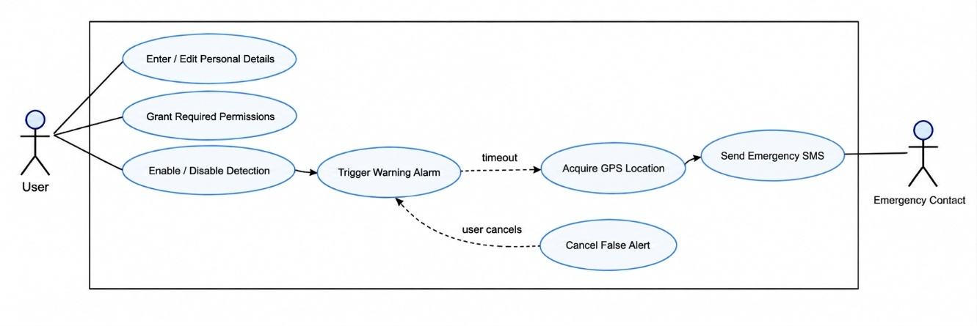
Figure 4.1: Use Case Diagram of Accident Detection and Alert System

4.2 Class Diagram
The class diagram models the main logical responsibilities of user details, detection control, sensor monitoring, location, alerting and local storage.
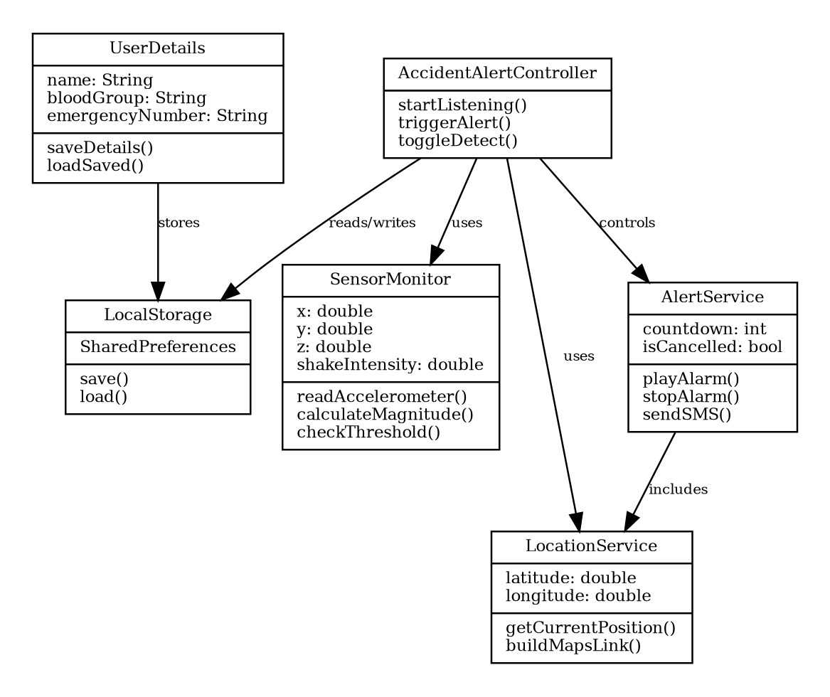
Figure 4.2: Class Diagram of Accident Detection and Alert System

4.3 State Diagram
The state diagram represents transitions from idle to monitoring, possible accident, warning, location retrieval and message dispatch.
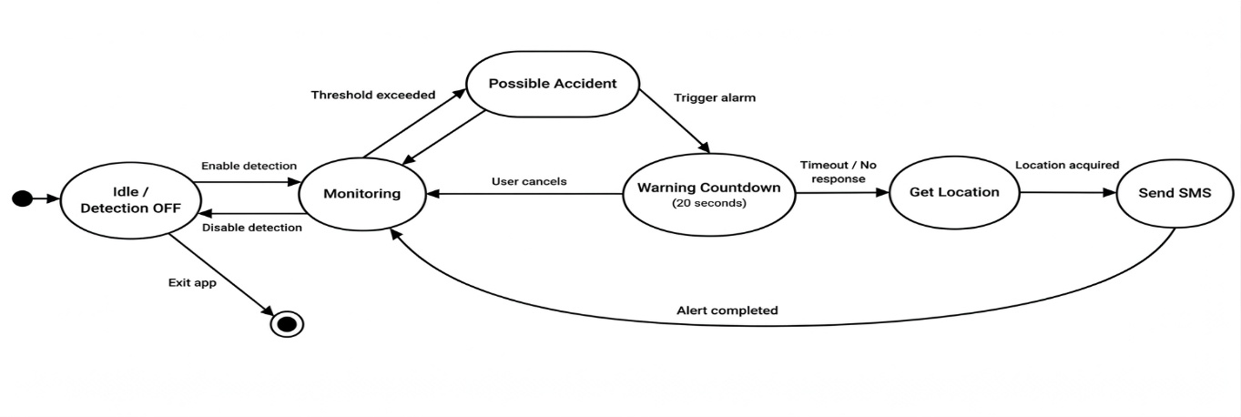
Figure 4.3: State Diagram of Accident Detection and Alert System

4.4 Activity Diagram
The activity diagram emphasizes the decision points for threshold detection and user cancellation.
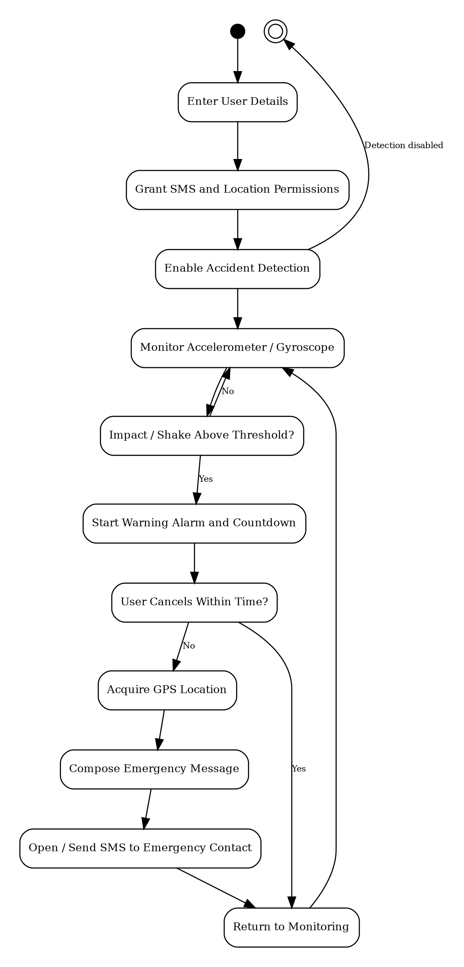
Figure 4.4: Activity Diagram of Accident Detection and Alert System

4.5 Sequence Diagram
The sequence diagram presents the time-ordered interactions among the user interface, controller, sensors, location service and emergency messaging service.
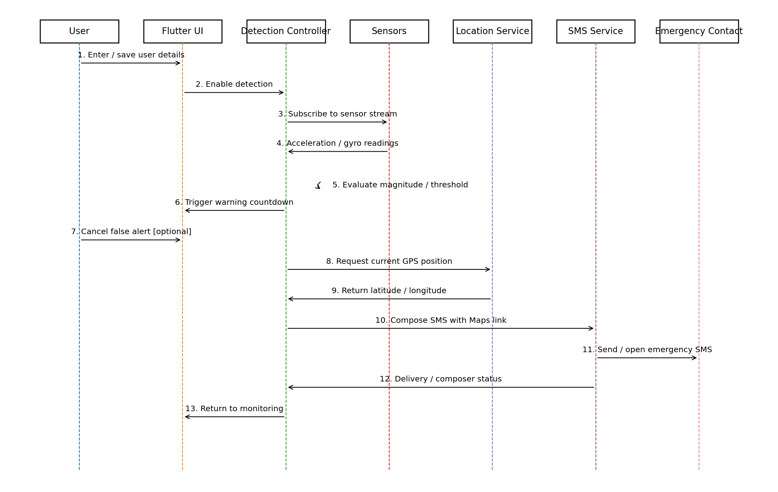
Figure 4.5: Sequence Diagram of Accident Detection and Alert System

CHAPTER 5
METHODOLOGY

5.1 Module Descriptions
The Accident Detection System application is divided into two main modules for smooth operation and real-time detection.. Each module has a focused responsibility so that sensing, emergency handling and user configuration remain understandable and maintainable.
Table 5.1: User and System Modules of the Accident Detection and Alert System
No. | Module | Responsibility
1 | User Details and Settings Module | Collects, validates and stores the user name, blood group and emergency contact number, and reloads them when the page opens.
2 | Detection Control Module | Provides the Accident Detection switch, checks that user details exist before enabling detection, stores the detection state and starts accelerometer listening.
3 | Sensor Monitoring Module | Receives X, Y and Z acceleration values, calculates the magnitude and applies the sliding-window, threshold, spike and cooldown conditions.
4 | Alert Generation Module | Plays the looping warning alarm and provides the confirmation period in which a false alert can be cancelled.
5 | Location Tracking Module | Checks location services and permission, retrieves a high-accuracy position and builds the Google Maps link.
6 | Emergency Message Module | Prepares the emergency message and opens the SMS composer; keeps the message as unsent data if the SMS action cannot be launched.
7 | Local Storage and Permission Module | Stores user details, detection state and unsent message in SharedPreferences and manages location and messaging permissions.

5.1.1 User Details and Settings Module
This module collects the user name, blood group and emergency contact number. The source implementation loads previously stored values when the page opens and validates that all required fields are filled before saving. SharedPreferences is used to persist the values. The page can later be reopened to edit the information.
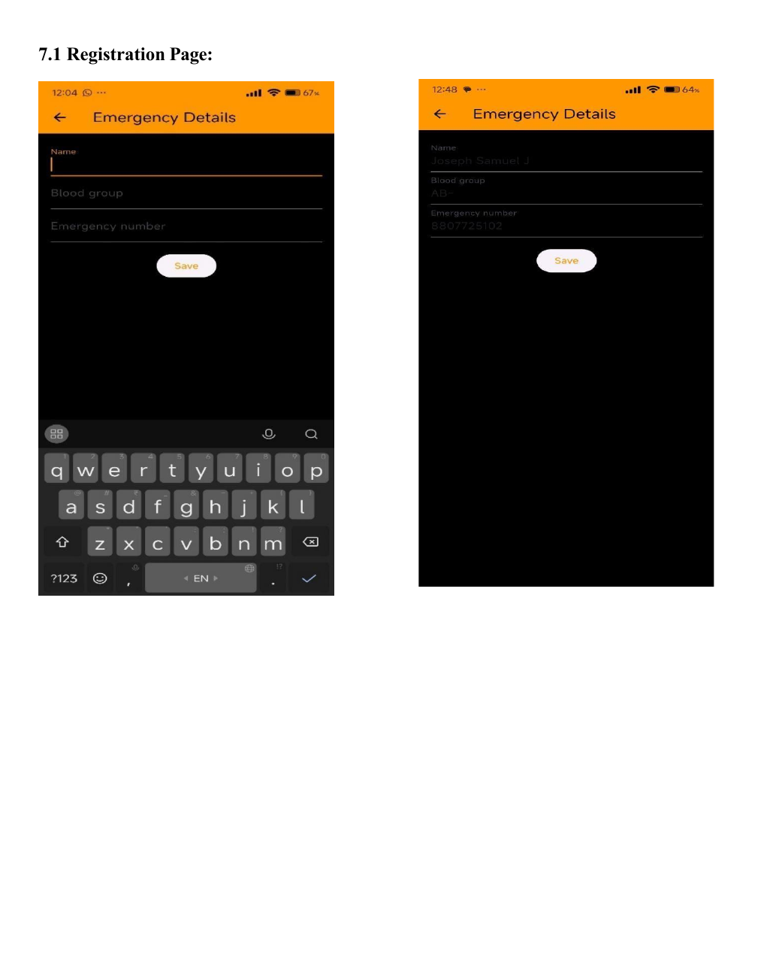
Figure 5.1: Registration / Emergency Details Screen

5.1.2 Detection Control Module
The main screen provides an Accident Detection switch. If detection is enabled before the required user details are available, the app displays a warning and redirects the user to the
details screen. The detection state is stored so that the application can restore it. When enabled, the app starts listening to accelerometer events.
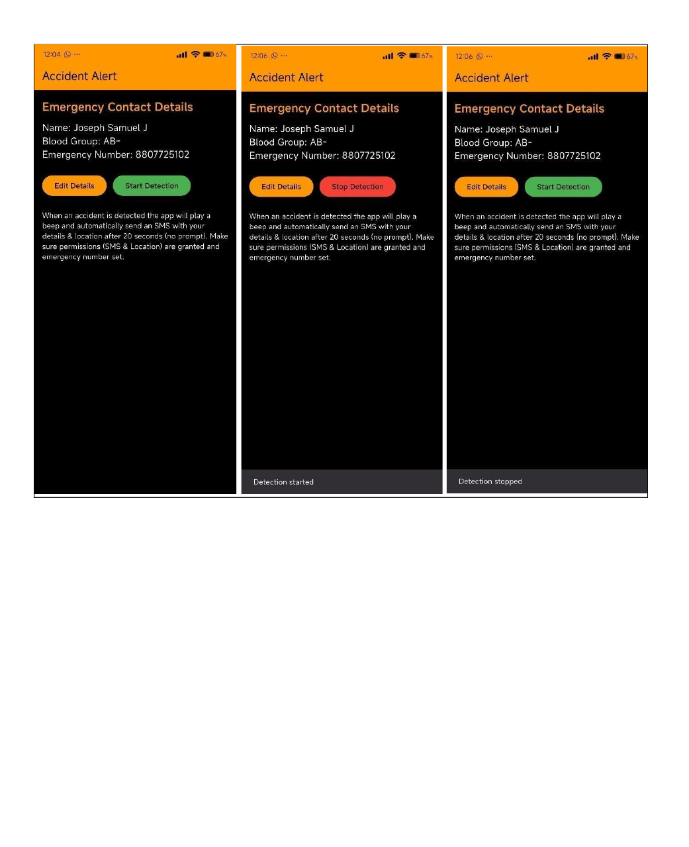
Figure 5.2: Main Accident Detection Screen

5.1.3 Sensor Monitoring Module
The sensor module receives acceleration values along the X, Y and Z axes. The total magnitude is calculated as the square root of x² + y² + z². Recent magnitudes are stored in a small sliding window. The implementation compares the current magnitude with both an absolute threshold and the recent average, allowing it to react to a large absolute event or a sudden spike. A cooldown interval is used so that a single impact does not immediately trigger several repeated alerts. The original source uses a window size of eight readings, an absolute threshold of 25.0, a spike delta of 12.0 and an eight-second cooldown. These are prototype values and may require calibration for different devices.

5.1.4 Alert Generation Module
When the detection condition is satisfied, the alert module plays a looping audio file to attract the user’s attention. The documented workflow includes a confirmation period in which the user can dismiss a false event. If the user does not respond, the workflow proceeds to obtain location and prepare the emergency message. This confirmation stage is an important design control because smartphone motion alone cannot perfectly distinguish every crash from every non-crash movement.

5.1.5 Location Tracking Module
The location module first checks whether location services are enabled and then verifies the application permission. When required, it requests permission and retrieves a high-accuracy position through the Geolocator package. Latitude and longitude are converted into a Google Maps query URL. This representation is useful because the emergency contact can open the link directly on a mapping application.
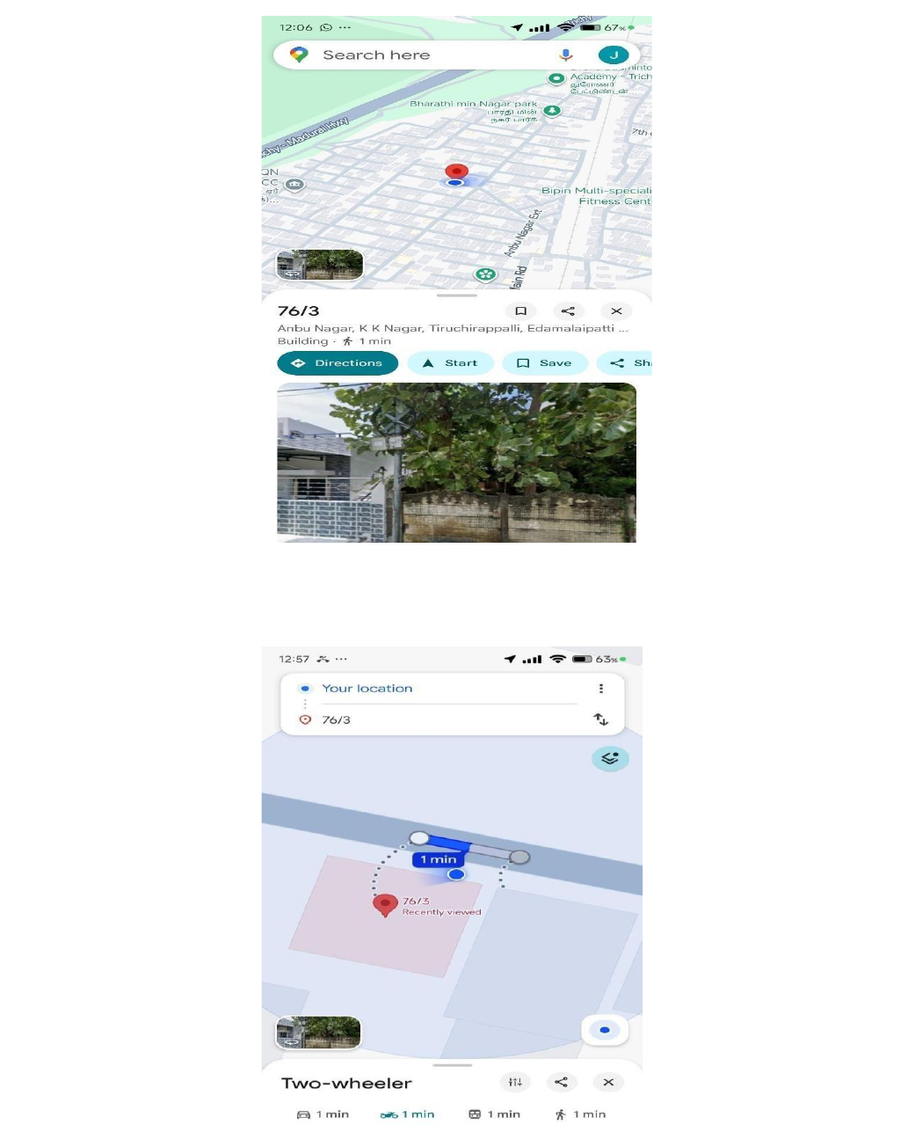
Figure 5.3: Live Location / Google Maps Output

5.1.6 Emergency Message Module
The emergency message contains an accident alert followed by available user details and the Google Maps location link. The source project uses an SMS URI so that the phone can open the SMS composer with the recipient and body prepared. If the SMS action cannot be launched, the message text is stored locally as an unsent message and can later be reopened.
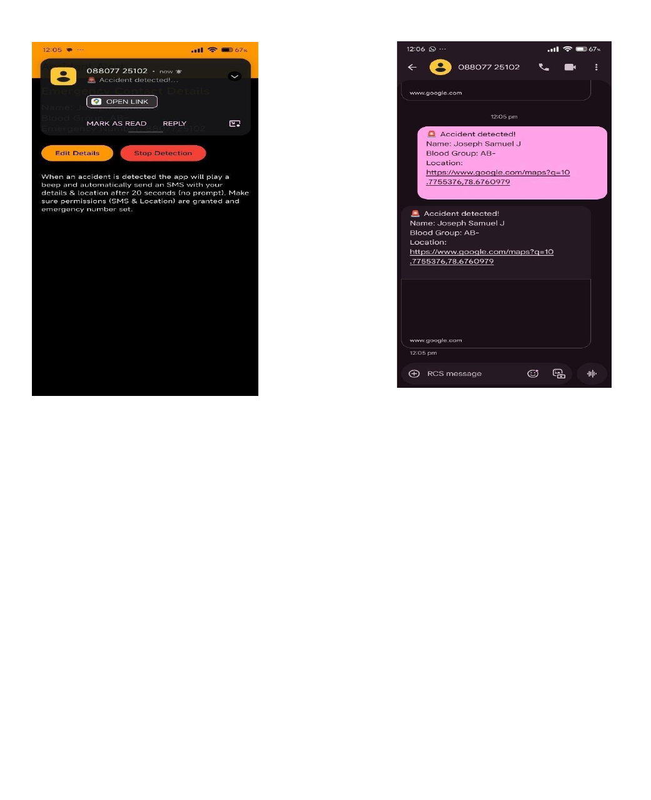
Figure 5.4: Emergency Message Notification / SMS Output

5.1.7 Local Storage and Permission Module
SharedPreferences stores the user name, blood group, emergency number, detection state and any unsent message. The permission handler and Android manifest manage access to location and messaging-related capabilities. Local storage is intentionally minimal and does not require an external database server.

5.2 Algorithms
The application uses a small set of deterministic algorithms that run entirely on the device. They cover sensor data collection, acceleration magnitude calculation, sliding-window spike detection, cooldown control, emergency escalation with false-alert cancellation, location retrieval and emergency message generation. The detection logic is threshold-based and does not use machine learning.

5.2.1 Sensor Data Collection and Acceleration Magnitude Calculation
When detection mode is enabled, the application subscribes to the accelerometer event stream provided by the sensors_plus package. Each event supplies acceleration values along the X, Y and Z axes of the phone.
For each accelerometer event, the magnitude is computed as M = √(x² + y² + z²). This converts three-axis motion into a single scalar value that can be compared with a threshold. Because gravity contributes to the magnitude, the chosen threshold must be significantly above ordinary stationary or low-motion readings.
M = √(x² + y² + z²)

5.2.2 Sliding-Window Spike Detection
The most recent values are maintained in a fixed-size window. The average of the window provides a short-term baseline. A possible accident is detected when either the absolute magnitude exceeds the absolute threshold or the difference between the current magnitude and the recent average exceeds a spike threshold. In conceptual pseudocode: read x, y, z; calculate magnitude; update window; calculate average; if magnitude > absoluteThreshold OR magnitude - average > spikeDelta, then evaluate cooldown and trigger the alert.
Steps:
- Read the acceleration values x, y and z from the accelerometer event.
- Calculate the magnitude M = √(x² + y² + z²).
- Append M to the sliding window; if the window exceeds eight readings, remove the oldest reading.
- Calculate the average of the values in the window as the short-term baseline.
- Check the absolute condition: magnitude is greater than the absolute threshold.
- Check the spike condition: magnitude minus the window average is greater than the spike delta.
- If either condition is true, evaluate the cooldown and, if it has elapsed, trigger the alert.
Table 5.2: Prototype Detection Parameters
Parameter | Value | Purpose
windowSize | 8 readings | Number of recent magnitudes kept to estimate the short-term average
absoluteThreshold | 25.0 | Magnitude above which an event is treated as a possible accident
spikeDelta | 12.0 | Difference between the current magnitude and the recent average that indicates a sudden spike
cooldownMs | 8000 ms (8 seconds) | Minimum interval between two accepted detections

These are prototype calibration values and may require calibration for different devices.

5.2.3 Cooldown Logic
The detection timestamp is compared with the previous event timestamp. A new event is accepted only when the configured cooldown has elapsed. This prevents one physical impact from generating many rapid alerts from successive high sensor samples.

5.2.4 Emergency Escalation Logic and False-Alert Cancellation
After a suspected accident, the alarm is started and the user is given a chance to cancel. If the alert is cancelled, no emergency message is sent and monitoring continues. If the warning expires, the application retrieves GPS coordinates, constructs the message and initiates the SMS action. The documented mini-project requirement specifies a 20-second confirmation window. The supplied source-code excerpt contains timing values that should be kept synchronized with this documented requirement in the final build.
Steps:
- Start the looping warning alarm and display the warning to the user.
- Give the user a confirmation window in which the alert can be cancelled.
- If the alert is cancelled, stop the alarm; no emergency message is sent and monitoring continues.
- If the warning expires without cancellation, proceed to location retrieval and emergency message generation.

5.2.5 Location Retrieval and Emergency Message Generation
After escalation, the application obtains the current position and prepares the emergency message that is addressed to the saved emergency contact.
- Check whether location services are enabled and verify the application permission; request permission when required.
- Retrieve a high-accuracy position through the Geolocator package.
- Convert the latitude and longitude into a Google Maps query URL.
- Compose the emergency message containing the accident notice, the stored name and blood group, and the Google Maps link.
- Encode the message in an SMS URI addressed to the stored emergency number and open the SMS action.
- If the SMS action cannot be launched, store the message locally as an unsent message so that it can be reopened later.

5.3 Architecture
The architecture is entirely mobile-centric. The Flutter UI communicates with an accident-detection controller. Sensor events enter from sensors_plus; configuration and user data are read from SharedPreferences; the controller activates audio, requests the GPS location, and invokes the SMS/URL mechanism. No external application server is required for the core prototype.
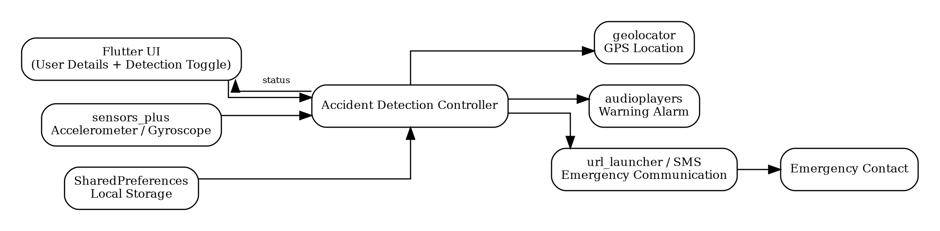
Figure 5.5: System Architecture of Accident Detection and Alert System
The flow of control through the architecture is: the User enables detection on the Flutter UI; the Sensor Monitoring component reads accelerometer events; the Detection Algorithm evaluates the threshold, spike and cooldown conditions; the Warning/Confirmation stage plays the alarm and allows cancellation; the GPS Location component retrieves the coordinates; and the Emergency Message/SMS component addresses the message to the Emergency Contact. SharedPreferences provides local storage for user details, detection state and any unsent message throughout this flow.
Architectural Components
- User and Flutter UI: the user enters details and controls the detection switch through the Flutter interface.
- Accident-detection controller: coordinates sensor events, audio, location and the SMS/URL mechanism.
- Sensor input: accelerometer events are supplied through sensors_plus.
- Local storage: configuration and user data are read from and written to SharedPreferences.
- Output: the controller activates the warning audio, requests the GPS location and invokes the SMS/URL mechanism to reach the emergency contact.
No external application server is required for the core prototype.

5.4 Case Study
Consider a user named Sam who has saved blood group O+ and an emergency contact number. Before beginning a journey, Sam enables Accident Detection. The application subscribes to the accelerometer stream and continuously calculates motion magnitude. Normal vehicle vibration remains below the configured conditions, so no warning is shown.
A sudden high-impact movement causes the magnitude to exceed the detection condition. The application starts the alarm and displays the warning. If Sam is safe and the event was caused by a pothole or accidental phone drop, the alert can be cancelled. No message is generated, and the system returns to monitoring.
If Sam is unable to respond, the warning expires. The app checks location permission, obtains the current position, and creates an emergency message such as “Accident detected! Name: Sam; Blood Group: O+; Location: [Google Maps link].” The recipient can open the link to view the location. This scenario illustrates the intended value of the application: reducing dependence on the victim’s ability to manually describe the situation and location.
The case study also illustrates the key limitation of threshold detection. A sufficiently violent non-accident motion may trigger the same sequence. The cancellation stage therefore acts as a practical safeguard, while future machine-learning and context-aware methods can improve automatic discrimination.

CHAPTER 6
IMPLEMENTATION DETAILS

6.1 Implementation Procedures
The project is implemented as a Flutter application. Development begins with creation of the Flutter project and configuration of dependencies in pubspec.yaml. The sensor, geolocation, local-storage, audio and permission packages are then installed using flutter pub get. Required Android permissions are declared in AndroidManifest.xml.
The user-details screen is implemented first so that personal data and the emergency number can be entered, validated and stored. The application startup code checks SharedPreferences to decide whether the details page or main detection page should be displayed. This prevents accident monitoring from being activated before an emergency recipient is configured.
The main screen implements the detection toggle. When enabled, a sensor listener is started. Each accelerometer event is converted into a magnitude, appended to a small window and compared with the absolute and relative spike conditions. When a qualifying event occurs and the cooldown has elapsed, the alert routine is called.
The alert routine starts the audio warning, loads stored user details and checks location availability and permission. A current GPS position is requested and inserted into a Google Maps link. The message is encoded into an SMS URI for the stored emergency number. If the phone cannot open the SMS action, the message is retained locally as an unsent message and a button is provided to retry later.
Implementation is validated on a physical smartphone because accelerometer, gyroscope, GPS and SMS behaviour cannot be fully reproduced by a desktop environment. Threshold testing is performed carefully using controlled movements rather than dangerous real-world crash simulation.
The implementation environment consists of Flutter and Dart for the application, sensors_plus for accelerometer events, geolocator for location, SharedPreferences for local storage, audioplayers for the warning sound, permission_handler for runtime permissions, url_launcher for the SMS/URL mechanism, and the Android SDK with Gradle as the build tools. The user interface of the principal screens is shown in Figures 5.1 to 5.4 of Chapter 5: the Registration / Emergency Details screen (Figure 5.1), the Main Accident Detection screen (Figure 5.2), the Live Location output (Figure 5.3) and the Emergency Message notification (Figure 5.4).

6.2 Testing Methods and Results
Testing was carried out to verify that the modules of the application function correctly and work together as expected. Because the application depends on real sensor, GPS and messaging behaviour, the testing strategies described below were applied to the prototype, and the resulting test cases are tabulated in Section 6.3.
- Functional Testing: Verifies saving user details, detection control, sensor-event handling, warning generation, cancellation behaviour, location retrieval and emergency-message creation.
- Usability Testing: Checks whether labels, input fields, buttons and warnings are understandable and whether the workflow can be completed without technical knowledge.
- Device and Compatibility Testing: Runs the application on Android devices with different screen sizes and sensor characteristics. Permission behaviour is verified for the target Android version.
- Location Testing: Compares the generated Google Maps link with the physical test location and verifies permission-denied and location-disabled conditions.
- Emergency Message Testing: Checks recipient number, message content, encoded location link and the unsent-message fallback when an SMS action cannot be launched.
- Persistence Testing: Closes and reopens the app to confirm that personal details and detection state are stored as expected.
- Safety-Oriented Testing: Avoids real collisions or hazardous driving. Sensor events are simulated by controlled hand movements or low-risk bench tests.
The test cases for the user details page, accident detection and SMS/location workflow were executed on the prototype, and the status recorded for each case in Tables 6.1 to 6.3 is Pass.

6.3 Test Cases

6.3.1 User Details Page Test Cases
Table 6.1: User Details Page Test Cases
ID | Scenario | Steps / Data | Expected Result | Actual Result | Status
1 | Enter user name | Type Name = Sam | Name is saved and visible | Name saved and visible | Pass
2 | Enter blood group | Enter/select O+ | Blood group is saved | Saved successfully | Pass
3 | Enter emergency number | Enter 9876543210 | Number is saved and retrievable | Saved and retrievable | Pass
4 | Save details | Provide all fields and tap Save | Data persists and is usable by alert workflow | Data saved and persists | Pass
5 | Empty fields | Tap Save with required field empty | App shows “Please fill all fields” | Validation message shown | Pass

6.3.2 Accident Detection Test Cases
Table 6.2: Accident Detection Test Cases
ID | Scenario | Action / Data | Expected Result | Actual Result | Status
1 | Enable detection | Turn ON Accident Detect | Sensor monitoring starts | Monitoring started | Pass
2 | Disable detection | Turn OFF detection | Monitoring stops / no new alerts | Monitoring stopped | Pass
3 | Normal movement | Walk / normal drive-like movement | No accident alert | No alert triggered | Pass
4 | Minor shake | Controlled small jerk | Warning may appear according to threshold; can be dismissed | Popup / warning displayed | Pass
5 | Dismiss false alert | Cancel warning | Alarm stops and no SMS is sent | Alarm stopped; no SMS | Pass
6 | Major shake | Controlled stronger simulated movement | Alarm and warning countdown start | Alarm started and warning shown | Pass
7 | Ignore alert | Do not dismiss | Emergency message generated after confirmation period | Message generated | Pass
8 | Multiple shakes | Repeat rapid movement | Cooldown prevents repeated alerts for same event | Single event handled | Pass
9 | Alarm sound | Allow warning to run | Warning audio continues until stopped by workflow | Audio played | Pass

6.3.3 SMS and Location Test Cases
Table 6.3: SMS and Location Test Cases
ID | Scenario | Expected Result | Actual Result | Status
1 | Emergency message content | Contains accident notice, name, blood group and Google Maps location | Correct content generated | Pass
2 | Message after timeout | Message workflow begins after user does not cancel warning | Workflow initiated | Pass
3 | No message when cancelled | Cancellation prevents emergency escalation | No emergency message | Pass
4 | Location accuracy | Latitude and longitude open correct Maps location | Location link correct | Pass
5 | Location permission denied | App requests permission or prevents location step gracefully | Permission flow displayed | Pass
6 | SMS action unavailable | Message is retained as unsent data for retry | Unsent message saved | Pass

6.4 Implementation Consistency Note
The project report describes a 20-second user confirmation period before emergency escalation. The supplied code excerpt contains a timer that stops the alarm after 10 seconds and also launches the SMS URI within the alert routine. These values and execution steps should be synchronized in the final submission build so that the implemented behaviour exactly matches the documented 20-second workflow. This report preserves the documented project requirement and explicitly identifies the implementation snapshot difference rather than silently changing the original source.

CHAPTER 7
ADVANTAGES AND DISADVANTAGES

7.1 Advantages
The Accident Detection and Alert System brings detection, location and emergency communication into a single smartphone application. Its main advantages are:
- Low hardware cost because the solution uses sensors already available in a smartphone.
- Rapid detection and location-aware emergency communication can reduce reporting delay.
- Simple user interface with minimal configuration.
- Local storage avoids dependence on a dedicated external database for essential settings.
- GPS coordinates are converted into an easy-to-open Google Maps link.
- False alerts can be cancelled before escalation.
- Modular Flutter design makes the project maintainable and extendable.
- The approach can be useful to drivers, riders, cyclists and users in isolated environments.
- The project provides a practical foundation for AI/ML-based sensor fusion and health-monitoring enhancements.

7.2 Disadvantages
Although the system provides a low-cost safety mechanism, it has the following limitations:
- Threshold-based detection can produce false positives from phone drops, potholes or abrupt but non-accident movements.
- Accuracy depends on phone placement, device sensor quality and calibration.
- An SMS or message action still depends on cellular service and device permissions.
- GPS may be slow or inaccurate indoors, in tunnels or in areas with limited satellite visibility.
- Aggressive background monitoring can increase battery consumption and may be restricted by modern Android background-execution policies.
- A smartphone-only solution cannot directly access vehicle crash data unless additional integration is added.
- The current prototype does not automatically contact the nearest hospital or government emergency dispatch system.
- The supplied implementation requires final alignment between the documented confirmation timing and the code snapshot.

CHAPTER 8
RESULT AND DISCUSSION

8.1 Functional Results
The implemented system successfully demonstrates the complete prototype workflow: capturing and saving emergency details, enabling sensor monitoring, detecting high-motion events, producing a warning, obtaining location and generating an emergency message with a Google Maps link. The user-detail validation and local-storage behaviour support repeated use without re-entering information on every launch.
Table 8.1: Functional Result Summary
Function | Observed Result | Status
User details storage | Name, blood group and emergency number stored locally | Pass
Detection toggle | Monitoring can be enabled/disabled | Pass
Normal movement handling | No alert during ordinary controlled movement | Pass
Abnormal motion handling | Warning generated under strong simulated motion | Pass
False-alert handling | User can cancel before emergency action | Pass
GPS location | Coordinates embedded in Maps link | Pass
Emergency message | Personal data and location included | Pass
Persistence | Saved details available after reopening | Pass

8.2 Discussion of Detection Behaviour
The use of both an absolute magnitude threshold and a difference from the recent average provides a simple form of contextual detection. The absolute threshold reacts to clearly large acceleration, while the spike condition reacts to a sudden deviation from recent motion. The sliding window smooths the baseline and the cooldown prevents repeated triggers from the same event. These choices make the algorithm easy to explain and suitable for an academic prototype.
However, a deterministic threshold does not provide a universal definition of an accident. Sensor output differs across devices, and the same physical event can produce different readings depending on whether the phone is fixed to the vehicle, carried in a pocket or placed loosely on a seat. The confirmation alarm is therefore an essential part of the prototype rather than merely a user-interface feature.

8.3 Discussion of Emergency Communication
The location-aware message is the most practically useful output of the project. Latitude and longitude alone may be difficult for a recipient to interpret quickly, while a Google Maps link can be opened directly. Including the user’s name and blood group adds context. The unsent-message fallback is also valuable because it avoids losing the emergency text when the SMS action cannot be opened immediately.
The current approach should be understood as a prototype emergency aid rather than a certified emergency dispatch mechanism. Direct SMS transmission may be restricted by platform policy or require user interaction depending on Android version and package behaviour. A production system would require a carefully tested communication strategy, clear consent, privacy safeguards and integration with local emergency-service rules.

8.4 Overall Analysis
The project meets its primary educational and functional objective by integrating several mobile-device capabilities into one safety workflow. It shows that a smartphone can serve as a compact sensing, processing, location and communication platform. The solution is especially attractive for a mini project because the architecture is visible and explainable: data enters from sensors, a detection condition is evaluated, the user is warned, location is obtained, and a message is generated.
The literature review indicates that advanced systems reduce false positives through sensor fusion, vehicle data, acoustic context or machine learning. The present implementation is therefore best viewed as a baseline system. Its value lies in simplicity, low deployment cost and a clear path for improvement. The most important next technical step would be to collect labelled normal-motion and simulated-impact data from multiple devices and replace fixed thresholds with a calibrated or learned classifier.
The observations of this chapter can be separated into demonstrated prototype behaviour, limitations and future improvements:
- Demonstrated prototype behaviour: user details are saved and validated; detection can be enabled and disabled; normal movement raises no alert; strong simulated motion produces a warning; a false alert can be cancelled before emergency action; the location is embedded in a Google Maps link; and the emergency message contains personal data and location.
- Limitations: the threshold-based detector is device-dependent and does not provide a certified accident-detection accuracy; emergency communication depends on SMS capability and platform restrictions; and the confirmation timing of the implementation snapshot must be aligned with the documented workflow.
- Future improvements: collection of labelled normal-motion and simulated-impact data from multiple devices to replace fixed thresholds with a calibrated or learned classifier, together with the enhancements listed in Section 9.3.

CHAPTER 9
CONCLUSION

9.1 Summary

The Accident Detection and Alert System Using Smartphone Sensors was designed to reduce the delay between an accident and the first emergency notification. The application uses the smartphone accelerometer and gyroscope/motion sensing capability to identify sudden abnormal movement. It stores essential user data locally, provides a warning stage to handle false detections, obtains GPS coordinates and prepares an emergency message containing a Google Maps location link. The system continuously monitors sensor values and compares the detected motion patterns with predefined threshold conditions to identify possible accident situations. When an abnormal event is detected, the warning mechanism gives the user an opportunity to cancel the alert if the detection is caused by normal activities or accidental movement. This approach helps reduce unnecessary emergency notifications while maintaining a simple and responsive user interaction. The integration of sensor monitoring, location services and automated message preparation also demonstrates how multiple smartphone capabilities can be combined to create a practical safety-oriented application. The system is implemented with Flutter and Dart using mobile packages for sensing, location, local storage, audio and device actions.

The project demonstrates that useful emergency functionality can be created without specialized external hardware. It also illustrates important software-engineering concerns such as permission handling, state persistence, real-time event streams, threshold calibration and safe testing. Functional test cases confirm the intended prototype workflow for user details, detection control, alerts, location and message generation.

9.2 Limitations

Threshold values are device-dependent and require calibration. Different smartphones may produce different sensor readings due to variations in hardware and sensor sensitivity. Therefore, suitable threshold values must be calibrated and tested for reliable accident detection.

Phone placement can influence measured acceleration and rotation. The position and orientation of the smartphone, such as in a pocket, bag, or vehicle, can change sensor readings and may affect detection accuracy.

The application cannot guarantee detection of every accident or rejection of every non-accident movement. The system relies on predefined sensor thresholds, so sudden braking, dropping the phone, or other movements may sometimes cause false detection, while some accidents may not produce sufficient sensor values.

Location availability depends on GPS conditions and user permission. GPS accuracy can be affected by signal strength and environmental conditions. If location permission is denied or GPS is unavailable, an accurate accident location may not be obtained.

Emergency communication depends on SMS/cellular capability and platform restrictions. Successful message delivery requires network connectivity, SMS availability, and appropriate device permissions. Poor network conditions may delay or prevent communication.

The current design stores only minimal data and does not maintain a full accident-history database. The prototype focuses on the core detection and alert workflow and does not currently provide long-term accident records, cloud synchronization, or detailed event history.

No direct hospital, ambulance, or government emergency API integration is included. The system prepares emergency information and a location link but does not directly connect with emergency-response organizations or external emergency-service APIs.

The documented confirmation duration and source-code timing values must be synchronized in the final build. The confirmation time described in the documentation should match the actual value implemented in the source code, test cases, and final application to avoid inconsistencies during evaluation.

9.3 Future Scope

Machine-learning classification using labelled accelerometer and gyroscope sequences to reduce false positives. A machine-learning model can be trained using real and simulated accident sensor data to distinguish genuine accident patterns from normal activities such as walking, running, sudden braking, or dropping the phone. This can improve the accuracy and reliability of the detection system.

Adaptive sensitivity that learns each user’s usual movement patterns and phone placement. The system can learn the user's normal movement characteristics and typical smartphone placement over time. Based on this information, detection thresholds can be automatically adjusted to provide more personalized and accurate accident detection.

Multiple emergency contacts with prioritized escalation. The application can support several emergency contacts and notify them according to a predefined priority order. If the first contact does not respond within a specified period, the system could automatically proceed to the next contact.

Direct integration with local emergency numbers or approved emergency-service APIs where legally and technically supported. Future versions could connect directly with authorized ambulance, police, or emergency-response services. Such integration could allow accident information and location details to be transferred more quickly, subject to technical availability, legal requirements, and user consent.

Wearable-device integration for heart rate, oxygen saturation and fall-detection information. Smartwatches and other wearable devices could provide additional health and motion information. Combining these measurements with smartphone sensor data could provide a more comprehensive assessment of an accident situation.

Automatic voice prompt to determine whether the user is conscious and able to respond. After detecting a possible accident, the system could provide a voice prompt asking the user to confirm their condition. If the user does not respond within a specified time, the application could proceed with the emergency notification process.

Optional secure cloud history for accident analytics, subject to consent and privacy controls. Users could optionally store accident events securely in the cloud for future reference and analysis. Appropriate authentication, encryption, access control, and user consent would be required to protect sensitive information.

Detection of accident-prone locations and context-aware safety warnings. Historical accident information and location data could be analyzed to identify areas where accidents occur more frequently. The application could then provide appropriate safety warnings when the user enters such locations.

Battery-aware background monitoring and optimization for modern Android restrictions. Future development can improve background sensor monitoring while reducing battery consumption. The application could use efficient sensor sampling and Android-compatible background services to maintain monitoring without significantly affecting device performance.

Vehicle integration through Bluetooth/OBD-II to incorporate speed, airbag or diagnostic information. Integration with vehicle systems could provide additional information such as vehicle speed, engine status, diagnostic data, or airbag activation. Combining this information with smartphone sensor readings could improve accident detection and provide more detailed emergency information.

9.4 Applications
- Personal safety for drivers and passengers. The system can provide an additional layer of safety by detecting unusual motion associated with possible accidents and preparing an emergency notification with the user's location. It can be useful for both drivers and passengers during regular travel.
- Two-wheeler and bicycle safety where built-in automotive crash notification is unavailable. Motorcycles and bicycles generally have fewer built-in safety and crash-notification features than modern cars. A smartphone-based system can provide a low-cost alternative for detecting possible accidents and initiating an alert.
- Emergency support for users travelling through remote areas. The application can be particularly useful when users travel through locations where immediate assistance may not be easily available. Sharing the user's GPS location with emergency contacts can help them identify the approximate accident location more quickly.
- Fleet and field-worker safety when combined with organization-specific monitoring. The system can be extended for delivery personnel, service technicians, transport workers, and other field employees. With suitable organizational monitoring and privacy controls, accident alerts could help supervisors respond to incidents involving employees.
- Research platform for mobile sensor fusion and intelligent transportation studies. The application can serve as a foundation for research involving accelerometer, gyroscope, GPS, and other smartphone sensor data. Researchers can use the platform to study movement classification, accident detection, sensor fusion, and intelligent transportation applications.
- Foundation for smart-city emergency-response integration. The system can potentially be integrated with larger smart-city platforms that coordinate location information and emergency notifications. Such integration could support faster information sharing between users and authorized emergency-response systems.
- Educational demonstration of Flutter, sensor streams, GPS, local storage and mobile communication services. The project provides a practical example of how different mobile technologies can be combined to develop a real-world application. It can be used for demonstrating Flutter and Dart development, real-time sensor streams, GPS services, local data storage, permissions, alerts, and mobile communication features.

CHAPTER 10
APPENDICES

10.1 Sample Code

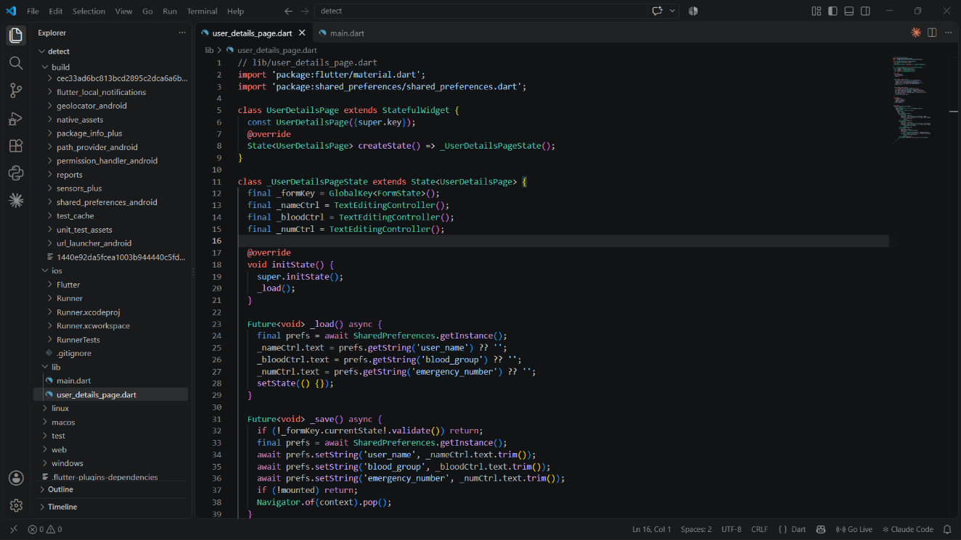

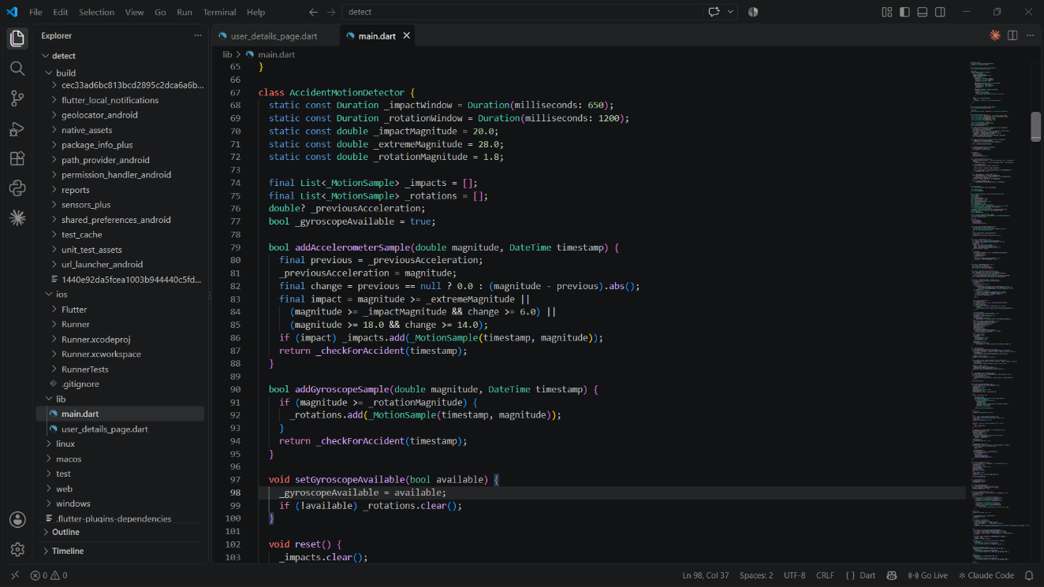

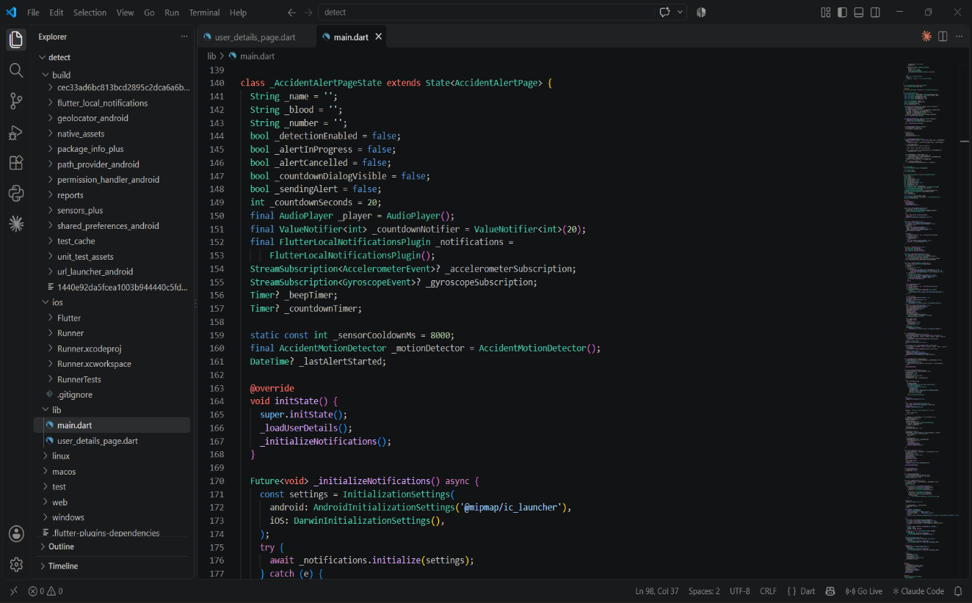

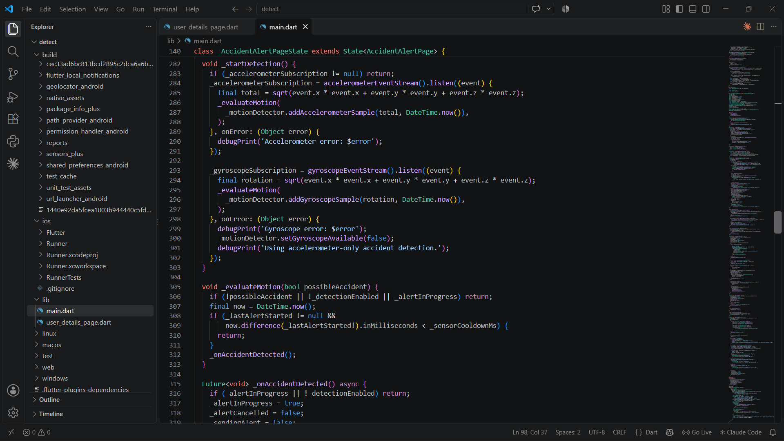

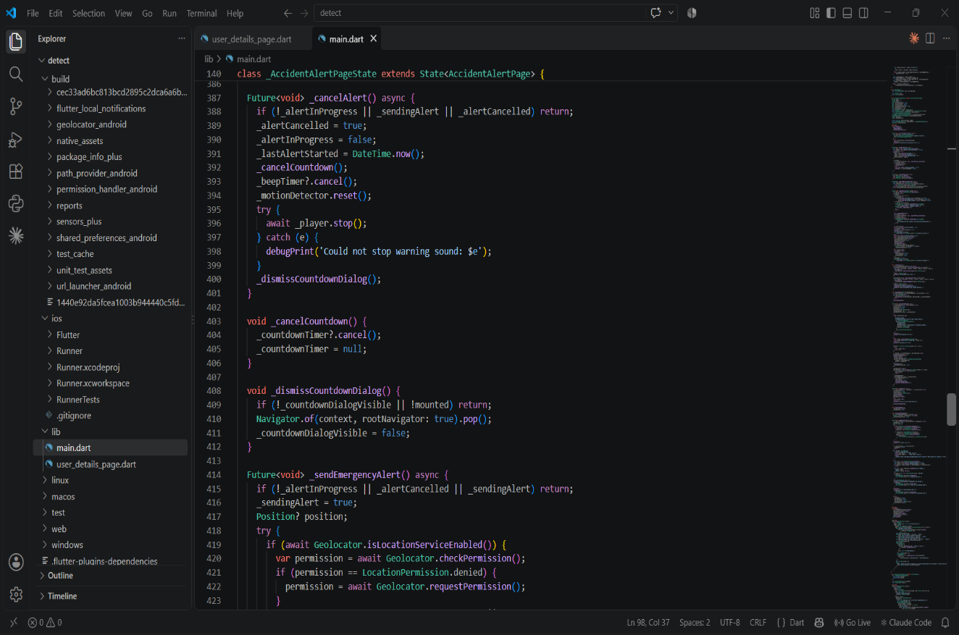

CHAPTER 11
REFERENCES
[1] Aloul, F. A., Zualkernan, I. A., Abu-Salma, R., Al-Ali, H., & Al-Merri, M. (2015). iBump: Smartphone application to detect car accidents. Computers & Electrical Engineering, 43, 66-75. https://doi.org/10.1016/j.compeleceng.2015.03.003
[2] Android Developers. (2026). Sensors overview and SensorManager API documentation. Android Developer Documentation.
[3] Bhatti, F., Shah, M. A., Maple, C., & Islam, S. U. (2019). A novel Internet of Things-enabled accident detection and reporting system for smart city environments. Sensors, 19(9), 2071. https://doi.org/10.3390/s19092071
[4] Dart. (2026). Dart language documentation. https://dart.dev/
[5] Fanca, A., Puscasiu, A., & Valean, H. (2016). Accident reporting and guidance system with automatic detection of the accident. 20th International Conference on System Theory, Control and Computing. https://doi.org/10.1109/ICSTCC.2016.7790657
[6] Fernandes, B., Alam, M., Gomes, V., Ferreira, J., & Oliveira, A. (2016). Automatic accident detection with multi-modal alert system implementation for ITS. Vehicular Communications, 3, 1-11. https://doi.org/10.1016/j.vehcom.2015.11.001
[7] Fernandes, B., Gomes, V., Ferreira, J., & Oliveira, A. (2015). Mobile application for automatic accident detection and multimodal alert. IEEE Vehicular Technology Conference (VTC Spring). https://doi.org/10.1109/VTCSpring.2015.7145935
[8] Flutter. (2026). Flutter documentation. https://docs.flutter.dev/
[9] Geolocator package. (2026). Flutter geolocation plugin documentation. https://pub.dev/packages/geolocator
[10] Google Maps Platform. (2026). Maps URLs documentation. Google Developers.
[11] International Telecommunication Union. (2024). Intelligent transport systems and emergency communication resources. ITU.
[12] Lahn, J., Peter, H., & Braun, P. (2015). Car crash detection on smartphones. Proceedings of the 2nd International Workshop on Sensor-based Activity Recognition and Interaction. https://doi.org/10.1145/2790044.2790049
[13] Lane, N. D., Miluzzo, E., Lu, H., Peebles, D., Choudhury, T., & Campbell, A. T. (2010). A survey of mobile phone sensing. IEEE Communications Magazine, 48(9), 140-150.
[14] Permission Handler package. (2026). Flutter permission_handler plugin documentation. https://pub.dev/packages/permission_handler
[15] Quick Accident Detection and Response System. (2020). Prototype proposal for quick accident detection and response system. 5th International Conference on Research in Computational Intelligence and Communication Networks. https://doi.org/10.1109/ICRCICN50933.2020.9296153
[16] ResQ - Accident Detection and Alerts App. (2025). Utilitas Mathematica.
[17] Roy, R. (2021). Flutter Mobile Development for Beginners. Packt Publishing.
[18] Sensors Plus package. (2026). Flutter sensors_plus plugin documentation. https://pub.dev/packages/sensors_plus
[19] Shared Preferences package. (2026). Flutter shared_preferences plugin documentation. https://pub.dev/packages/shared_preferences
[20] URL Launcher package. (2026). Flutter url_launcher plugin documentation. https://pub.dev/packages/url_launcher
[21] Vehicle Accident Detection and Locating Using GSM and GPS. (2024). International Conference on Communication, Computing and Internet of Things (IC3IoT). https://doi.org/10.1109/IC3IoT60841.2024.10550407
[22] White, J., Thompson, C., Turner, H. A., Dougherty, B., & Schmidt, D. C. (2011). WreckWatch: Automatic traffic accident detection and notification with smartphones. Mobile Networks and Applications, 16, 285-303. https://doi.org/10.1007/s11036-011-0304-8
[23] World Health Organization. (2023). Global status report on road safety 2023. WHO.
[24] World Health Organization. (2023). Road traffic injuries: Key facts. WHO.
[25] Yadav, S. et al. (2021). A survey on IoT based automatic road accident detection. 5th International Conference on Intelligent Computing and Control Systems (ICICCS). https://doi.org/10.1109/ICICCS51141.2021.9432159

